**P2P process for Subcontracting process**

The SAP subcontracting process involves sending components to a vendor to manufacture an assembly, which is then returned to the buyer:

1. **Create a subcontract order**: Enter the material to order and the item category for subcontracting (L) in the order item.
2. **Enter components**: Enter the components the vendor needs to manufacture the ordered material.
3. **Track components**: Track the components as they are shipped and consumed.
4. **Receive finished goods**: Send the finished goods back to the buyer.
5. **Issue components**: During goods receipt (GR), issue the components from subcontract inventory.

Subcontracting is a purchasing process that involves outsourcing part or all of manufacturing to an external company, also known as a subcontractor.

**Create Info Records:**

1. The transaction code for creation of Info record is ME11N
2. Info Record is used to create price condition record for a material and supplier combination for the services rendered by supplier
3. There are 04 types of info records namely standard, subcontracting, pipeline & Consignment and we would be using subcontracting info record
4. We need to pass material, supplier, purchase organization and plant for creating purchase info record
5. Maintain pricing condition for subcontracting service charges

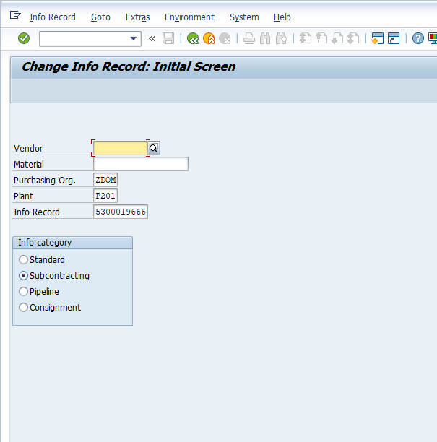

**Create Purchase Order:**

1. Use the transaction code : ME21N to create purchase order
2. Purchase Orders can be created with or without reference to purchase requisition
3. Create Purchase order by manually passing values for fields material Code, Quantity required , due date of delivery, plant for which items are required to be purchased. supplier code , item tax rate and price at PO line item
4. Use the Item category L which corresponds to subcontracting PO
5. System will ask you to provide components that would be supplied to vendor
6. These components will get consumed to produce finished or assembled product
7. Bill of material ( BOM) can also be created in advance that would help in automatically fetching child components while PO creation for subcontracting order
8. Save the purchase and system would generate a new number based on the number range assigned to PO document type in configuration

PO number gets generated and same needs to be approved before it can be used for subsequent activities like good receipt and invoice posting

**Release of Purchase Order**

1. System determines the release strategy based on the release strategy configuration
2. It also reads the master data maintained against class/ characteristics maintained in the system for release parameters
3. There are two ways to approve the purchase order
   1. Option1 : to approve the Purchase order through Transaction code: ME29N
   2. Option2: Setup workflow configuration, system will trigger work item in the inbox of approver
   3. Approver will use the Tcode: SBWP to approve purchase order
4. Post document approver further steps of good receipt can be executed
5. Save the approver action

**Transfer of components to supplier against Purchase Order**

1. Perform transfer posting by using SAP standard Tcode: MIGO against Purchase Order
2. System will default all the items that are required to be transferred to supplier
3. Post transfer posting stock will get removed from your plant and storage location and same gets available at supplier location
4. SAP standard stock reports shows the inventory available at vendor location

**Good receipt against Purchase Order**

1. Perform GRN by SAP standard Tcode: MIGO against Purchase Order
2. System will default all the open line items with open quantity for performing good receipt ( GRN)
3. User has to authority to change the default quantity in line with actual quantity received and also to specify the storage location where stock will be physically received and placed.

